Smart City (Networked Traffic Control for Autonomous vehicle)

# Group Member

1. Sheikh Muhammad Adib
2. Aditya
3. Mykyta
4. Rizwans
5. Farhad

# Progress:

Main Scenario for diagrams: A car want to cross an intersection.

Main part for implementation: Communication between components

|  |  |  |  |  |
| --- | --- | --- | --- | --- |
| Task | Sub Task | Responsibility | Status | Finalized |
| Task 1 |  |  |  |  |
| Discuss main Idea | Use case | Aditya | done | yes |
| Scenario |  |  | yes |
| Activity | Rizwan | todo |  |
| Mykyta | todo | yes |
| Farhad | todo | yes |
| Block Definition Diagram | Sheikh | done |  |
| Internal Block Diagram | Sheikh | done |  |
| Sequence Diagram | Aditya | done |  |
|  |  |  |  |  |
|  |  |  |  |  |
|  |  |  |  |  |
| Constraint and integration | Constraint Diagram | Farhad | done |  |
| Allocation Diagram | Mykyta | todo |  |
| Requirements diagram | Requirements | Rizwan | todo |  |
|  |  |  |  |  |
| Behaviour modelling | State machine for Traffic control unit | Sheikh | done |  |
|  | State machine for RSU | Aditya | done |  |
|  |  |  |  |  |
| Task 5 |  |  |  |  |
| scheduling | Task 1: signal (fix state sequence) | sheikh | done |  |
|  | Task 2: bus (extend time) | Rizwan | done |  |
|  | Task 3: Emergency (change the state sequence) | Aditya |  |  |
|  |  |  |  |  |
| WCET measurement | Task 1 | Sheikh | done |  |
|  | Task 2 | Rizwan | done |  |
|  | Task 3 | Aditya | todo |  |
|  |  |  |  |  |
| Verification (unitTest) | A Method in Task 1 |  | Todo |  |
|  | A Method in Task 1 | Farhad | Todo |  |
|  | A Method in Task 2 | Farhad | Todo |  |
|  | A Method in Task 2 | Farhad | Todo |  |
|  | A Method in Task 3 | Farhad | todo |  |
|  |  |  |  |  |
| Defect test | A Method in Task 1 | Mykyta | Todo |  |
|  | A Method in Task 1 | Mykyta | Todo |  |
|  | A Method in Task 2 | Mykyta | Todo |  |
|  | A Method in Task 2 | Mykyta | Todo |  |
|  | A Method in Task 3 | Mykyta | todo |  |
|  |  |  |  |  |
| Inspection | Sheikh |  | todo |  |
|  | Rizwan |  | todo |  |
|  | Aditya |  | todo |  |
|  | Farhad |  | todo |  |
|  | Mykyta |  | todo |  |
|  |  |  |  |  |
|  |  |  |  |  |
| Schedubility | Simulation and calculation | Sheikh |  |  |
|  |  |  |  |  |
|  |  |  |  |  |
|  |  |  |  |  |
| Task 4 |  |  |  |  |
| Internal Block Diagram | Task 1 | sheikh | done |  |
|  | Task 2 | Rizwan | done |  |
|  | Task 3 | Aditya | todo |  |
|  |  |  |  |  |
|  |  |  |  |  |
|  |  |  |  |  |
|  |  |  |  |  |
|  |  |  |  |  |
| Implementation | “task 5” |  |  |  |
|  |  |  |  |  |
|  |  |  |  |  |
| Finalize |  |  |  |  |
|  |  |  |  |  |
|  |  |  |  |  |
|  |  |  |  |  |
|  |  |  |  |  |

# Minutes Meeting

5/12

* Discuss and draft [1,2,3]
* Input prof:
  + Req: focus on what
  + Need refinement on each diagram.
  + Need to finalize a scenario.
* Todo:
  + Digitalize diagram.
  + Everybody should have a use case and define it using activity diagram.
  + Finalize scenario.

12/12

* Discuss use case
* Input Prof:
  + Use case should be more abstract
* Todo:
  + Refine usecase

14/12

* Refine use case
* Refine scenario
* Task Distribution (Diagrams)

18/12

* Task distribution

9/1

* Scheduling discussion
* Task Distribution

10/1

* Task redefinition
* Task distribution

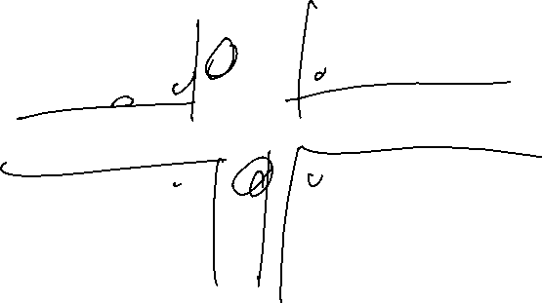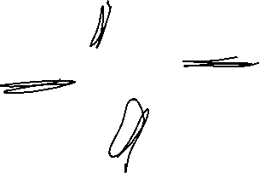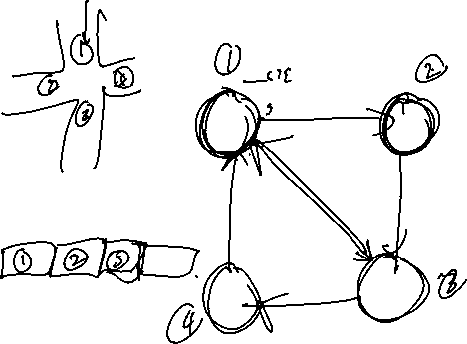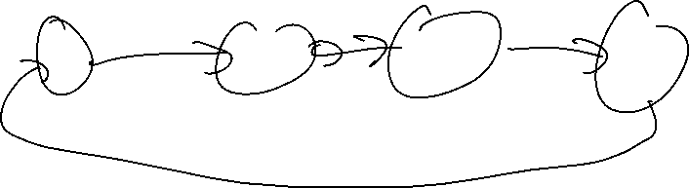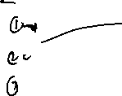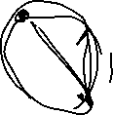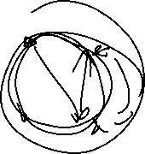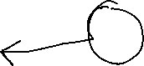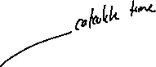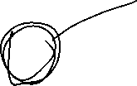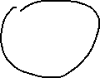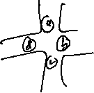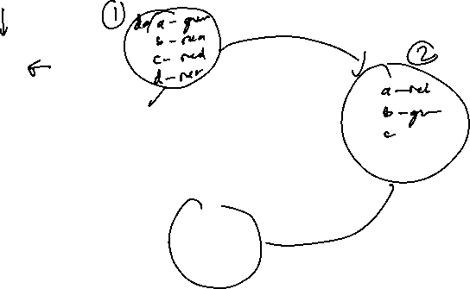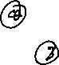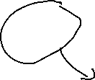

Free RTOS

|  |  |  |  |  |
| --- | --- | --- | --- | --- |
| Task | Description | period | WCET | priority |
|  |  |  |  |  |
| Change state |  |  |  |  |
| emergency |  |  |  |  |
| Bus |  |  |  |  |
|  |  |  |  |  |
|  |  |  |  |  |

Schedubility test

Scheduling -> RMS